
CARUS™ STRUVOUT
Dispersant and Sequestrant

Struvite scale formation is a recognizable problem where anaerobic sludge digesters are part of the solids handling treatment scheme. These crystals will deposit in digester supernatant recycle lines, especially at elbows and on the suction side of pumps. They can accumulate on screens and dewatering equipment as well as in filtrate/centrate pumps and lines returning this water back to the head of the plant. These scale formations cause unscheduled shutdowns, the loss of solids dewatering capacity, and increased operating costs. Chemical cleaning of the struvite scale and preventing future scale formation is the most cost effective method to eliminate unscheduled disruptions to plant dewatering operations.

BENEFITS OF CARUS™ STRUVOUT STRUVITE DISPERSANT AND SEQUESTRANT

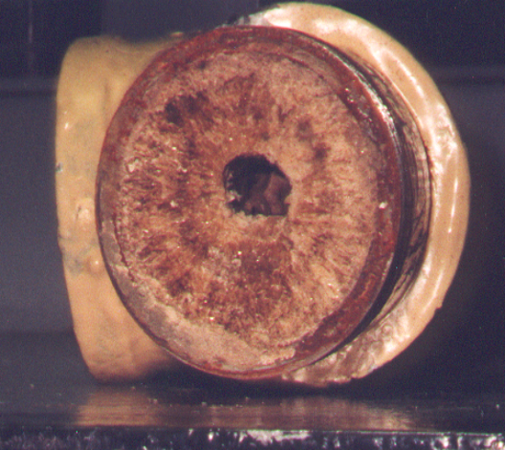
- Eliminates serious disruptions to plant dewatering operations by preventing deposits and plugging of equipment.

- Provides consistent dewatering operations; clean lines eliminate reductions in flow due to deposit build-up.

- Less down time, cleaning, and replacement of sludge dewatering lines or filtrate/centrate return lines.

- Eliminates scouring actions in the piping caused by breakaway deposits.

PROPERTIES AND CERTIFICATIONS
Struvite Scale Build-Up in an Elbow

- Clear liquid with light amber color
- Specific Gravity: 1.30-1.36
- Keep from freezing
- pH: 7.0±0.5
- Weight: 10.8-11.4 lbs. per gallon
- Contains sequestrants and dispersants
- The product is available in 30- and 275-gallon containers.

WHAT IS STRUVITE AND HOW DOES IT FORM?

Struvite is magnesium ammonium phosphate (MgNH₄PO₄•6H₂O). It forms in the anaerobic digestion process where the ammonia and orthophosphate react with the magnesium (hardness) present in the water. This is a case where more than one of the dissolved species (ammonium ion NH₄⁺ and phosphate ion PO₄³⁻) is affected by the solution pH. At pH 10.7, struvite solubility is at a minimum. In an anaerobic digester, the sludge is in contact with an atmosphere containing about 30-40% CO₂. When the sludge is exposed to air (containing 0.3% CO₂), CO₂ will be liberated from the sludge increasing the pH, and potentially exceeding struvite solubility, resulting in crystal formation. The problem magnifies itself in the filtrate/centrate lines because the component ions are concentrated.

APPLICATION

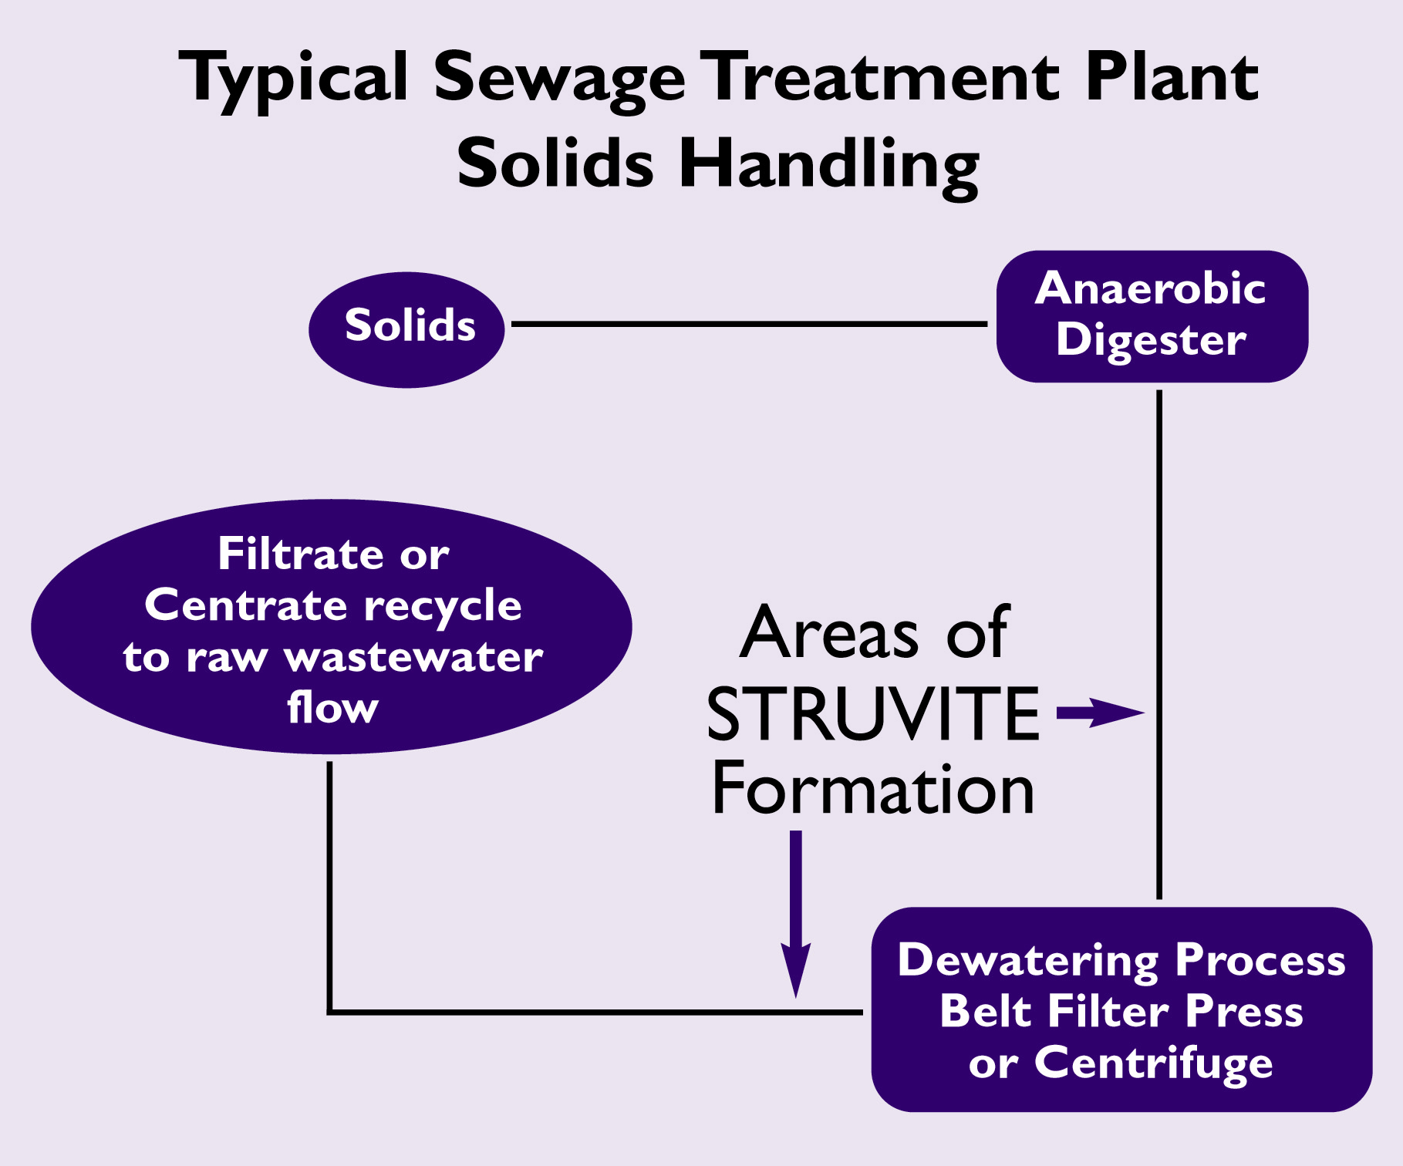
CARUS™ STRUVOUT dispersant and sequestrant is formulated to prevent scale under normal conditions. The product also contains a dispersant that will prevent scale formation under more severe conditions.
CARUS™ STRUVOUT dispersant and sequestrant is effective for sludge dewatering lines and equipment as well as in filtrate/centrate return lines to the head of the plant. The product is typically fed at 15-50 ppm dosages.
The information contained herein is accurate to the best of our knowledge. However, data, safety standards and government regulations are subject to change; and the conditions of handling, use or misuse of the product are beyond our control. Carus Corporation makes no warranty, either express or implied, including any warranties of merchantability and fitness for a particular purpose. Carus also disclaims all liability for reliance on the completeness or confirming accuracy of any information included herein. Users should satisfy themselves that they are aware of all current data relevant to their particular uses.


 (CARUS and Design) is a registered service mark of Carus Corporation.

CARUS™ is a trademark of Carus Corporation.
Responsible Care® is a registered service mark of the American Chemistry Council.

CARUS PHOSPHATES INC.
181 Woodlawn Ave • Belmont, NC 28012

Tel: (704) 822-1441 Fax: (704) 822-0922

E-Mail: salesmkt@caruscorporation.com
Web: www.caruscorporation.com
Copyright 2007
Form #PH
Rev. 107/07

